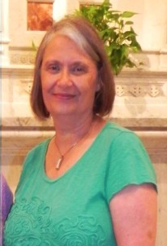
November 9, 2022

Dear Associates and Sisters,
Kathy Tracy entered this life and her eternal life on the same date in October. She was born on October 11, 1949, in Richmond, IN and died on October 11, 2022. Kathy lost her battle with cancer after years of living with multiple myeloma.
Kathy received her master’s degree in education at Indiana State University. She enjoyed anything having to do with being outdoors, including hiking, backpacking, camping and anything that would be considered adventurous, including being a crew member for a hot air balloon and flying in a hot air balloon at the Albuquerque International Balloon Fiesta. She also supported The Nature Conservancy.
Kathy was active at Northview Christian Church for a few years teaching in women’s ministry. It was there that she met Gerald Dunmire when serving communion together for the church. They were married on May 4th, 2014. They moved to Cicero, to a home with a beautiful, wooded lot full of the trails that Kathy loved to explore with her grandchildren. Kathy has two sons and six grandchildren.
Kathy was taught by Franciscans during her twelve years in Catholic Schools. Attracted to their charism and sense of community, she made her Associate commitment on September 11, 2016. Her statement reflected her love of nature and respect for all of life. The choices she made in her life emphasized her belief in prayer and in living a simple and grateful life.
May our loving God grant Kathy eternal peace and freedom from her earthly suffering,
Carolyn Meyer

