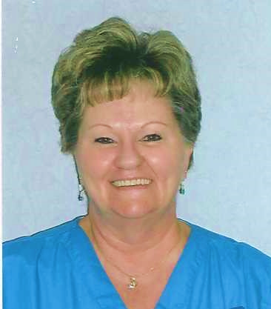
April 19, 2022

Dear Sisters and Associates,

On the evening of April 12, 2022, Associate Bonnie Duenne journeyed home to God. Bonnie was born June 26, 1951 in Connersville, Indiana to Frances (Anderson) and Leo Duenne.

Bonnie’s journey to becoming an Associate began many years ago as a young student at Taylor Creek School in Cincinnati. Taught by the Oldenburg Franciscans, Bonnie fell in love with the Community at a very young age. She later spent time at St. Peter’s in Indiana, sharing, “There was something special about the Sisters. I couldn’t quite put my finger on it, but I knew I wanted to be close to them.” Bonnie’s draw to the Oldenburg Franciscans was definitely spirit led. She proudly told the story of the day a UPS delivery came to her house by accident. The package was addressed to the Sisters of St. Francis, Oldenburg. Bonnie decided she would deliver it personally. Her story continued, “The Sister who greeted me at the door asked if I had ever visited before. I found myself telling her some of my story….I don’t know who the Sister was, but indeed she was an angel. She told me a little about the Associate Relationship and gave me an application,” under the guidance of Sisters Marie Schroeder (deceased) and Evelyn Forthofer, Bonnie signed her Associate commitment on April 18, 1999.

Bonnie’s love for the Oldenburg Franciscan Sisters did not end there. She began working as a Nurses Aid in St. Clare Hall in 2005 and continued her ministry until 2019. In a reflection she had written she shared, “I have been able to live out the Franciscan charism through my ministry in St. Clare hall as a nursing assistant.” She also enjoyed participating in the VIS (Very Important Sister) relationship.

Bonnie had many interests, hobbies, and Church ministries that helped her to grow in her love for God. She loved to cook and bake, and thought her homemade fudge was pretty good, she made crafts, gardened, sewed, and did cross stitch. Painting was also one of Bonnie’s hobbies and she was so pleased to know some of her paintings were sold in the Sister’s gift shop. Bonnie loved to sing and shared her gift of voice in Holy Family’s Choir. She also served as a Lector, Eucharistic Minister, Rosary leader, and at different times in her spiritual journey she served on the welcoming committee, chaired the Craft Booth for the Parish Festival, served on the Board of Religious Education, and helped with Bingo. In addition to these parish activities, Bonnie volunteered at the Michaela Farm Event, and the Salvation Army.

Those who knew Bonnie would probably add that one of her greatest gifts was her loving service and presence to others. She loved her ministry to the Sisters in St. Clare Hall. Sr. Laurencia Listerman (deceased) wrote a note stating, “Since I now live in St. Clare Hall, I know Bonnie as a ‘ray of sunshine’ early in the morning.” Sr. Patty Campbell shared in a letter recommending Bonnie for permanent commitment, “Bonnie radiates joy and acceptance as she walks the halls of St. Clare Hall, tending to our sisters. Sr. Evelyn Forthofer in a note also affirming Bonnie’s desire to make permanent commitment stated, “As I see her minister, I see a woman who treats each Sister with joy and dignity.” In sharing with Sr. Evelyn about Bonnie’s passing, she shared how Bonnie would sing for the sisters when she was caring for them. Sr. Marie Schroeder, Bonnies first contact person spoke of Bonnie saying, “Bonnie is a remarkable woman who values prayer and her own growth in the Spiritual Life.” Bonnie not only cared for the Sisters, she cared for both her parents in their final years as they journeyed home to God.

There is no doubt Bonnie grew deeper in her faith with each passing year. In her reflection for permanent commitment she wrote, “Through Franciscan living, I have learned the true meaning of joy, peace, love, trust and patience, not only in dealing with those I love and care for, but also in my relationship with God.” In one of her final written communications Bonnie stated, “I continue to live the gospel life and beatitudes, trying to be more Christ-like in all I do, and offering each day as a prayer.” On April 26, 2009 Bonnie made her commitment permanent.

Bonnie is survived by her children, Catherine Kocher, Timothy Frey, Carrie Frey, Carina Stout,
Stephanie Uhte, and Valerie Uhte; fiance’ William Brand, sister-in-law Martha Jo Duenne, 15 grandchildren and 2 great grandchildren. She was preceded in death by her parents and siblings, Joseph Duenne and Barbara Miller.

Bonnie, in gratitude for the loving presence you were to all those entrusted to you, may you now rest peacefully in the loving arms of God.

Jane Schaefer
Associate Co-Director

