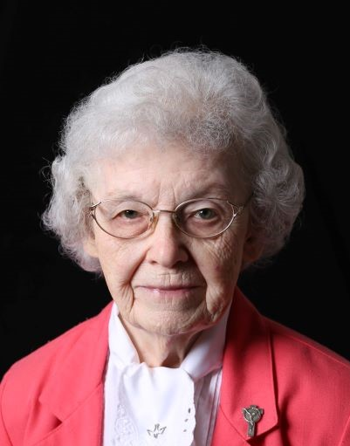
Sisters of St. Francis
PO Box 100 Oldenburg, IN 47036
www.OldenburgFranciscans.org

July 30, 2022

S. Dominica Doyle, OSF
Dear Sisters, Associates, Co-workers, Family and Friends,

Still basking in the glow of celebrating 80 years as a Sister of St. Francis, S. Dominica Doyle passed on to eternal life to be with her loving God on July 30, 2022.

Elizabeth Jane was born to Thomas and Margaret Doyle. She described them as the “best parents” she could have asked for. Her father was born in County Kerry, Ireland. How Irish was she! Betty Jane had a sister, Rosemary, and a brother, Thomas, who followed her. When reflecting on the treasures in her life, family always came to mind. Her mom and dad loved the Sisters and were always ready to offer their services. This made her feel part of the Franciscan family. Her own family’s togetherness was very important to her. Growing up in Indianapolis, she attended Our Lady of Lourdes grade school and went on to Immaculate Conception Academy as an aspirant having been encouraged by S. Ancilla Marie.

Her grandmother was a Dominican tertiary and she was very happy when Betty Jane told her that she was entering the Sisters of St. Francis at Oldenburg. Her grandmother’s reply was that Francis and Dominic were friends. In addition, there was a great aunt who was the Reverend Mother of a Dominican convent in Ireland and two uncles who were priests in Ireland. When others wondered why she entered a Franciscan order, she explained that all her formal education was with the Franciscan Sisters and the Dominican convent where her aunt was the novice director was too far away. It was in New Orleans. All of this led her to ask to be given the religious name of Dominica.

Dominica began her teaching career as a primary teacher, then moved on to the intermediate and junior high grades. Eventually she became a principal and eighth grade teacher at St. Michael School in Brookville, Indiana. For 39 years Dominica served not only as principal and teacher but also was in charge of the grade school CCD program, the Youth CYO program in the parish, and participated as a team member for RCIA. English was Dominica’s favorite subject. When students of hers moved on to high school, they were found to be outstanding in the area of English. Many of her students were winners in Speech contests. In 2001 she received the Distinguished Service award for 35 years of service to the Archdiocese of Indianapolis.

At a dinner in honor of S. Dominica in 2004 as she ended her time at St. Michael’s this quote from American historian Henry Adams (1838-1918) was applied to her: “A teacher affects eternity, she can never tell where her influence stops.” She encouraged and inspired students to do their best. She was a great support and example to her faculty, as well.
S. Helen Eckstein (deceased) and Dominica became a great team over those 39 years. S. Helen described her valued friend as an outstanding educator, counselor and English teacher, but she was even more. Weekly, Dominica took Communion to a nursing home and involved the students in visiting and volunteering to serve trays there. She received donations to be used in helping those who needed assistance and was glad to be able to offer assistance to many.

Outside of school, Dominica continued to show her leadership skills. When a devastating tornado hit Bright, Indiana, S. Jean Marie Cleveland, then pastoral associate at St. John’s, Dover, (of which Bright was part) called upon S. Dominica for help. Dominica organized a committee to prepare a meal that was delivered and served before the day was over.

When Dominica came home to “retire” she helped with Pastoral Care in St. Clare Hall on the first floor. Later, she volunteered in the Finance Office at Oldenburg Academy doing innumerable tasks. In 2015, she merited Oldenburg Academy’s Outstanding Volunteer of the Year award.

We extend our deepest sympathy to S. Dominica’s nieces and nephews, to classmate,
S. Jean Sora, and to her Sisters and Associates in Community. Our special thanks and sympathy to our nursing staff in St. Clare Hall and to the Pastoral Care team who so lovingly cared for S. Dominica, and to her many friends and beloved former students.

In gratitude for S. Dominica generously sharing her talents with so many,
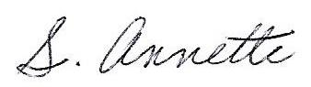

S. Annette Grisley
For the General Council

SISTER DOMINICA (Elizabeth) DOYLE
Birth: May 22, 1925
Entrance into Religious Life: September 8, 1942
Entrance into Eternal Life: July 30, 2022

MISSIONS AT WHICH S. DOMINCA SERVED:
1945-1946 St. Mary, Bloomington, IL
1946-1947 St. Bernard, Taylor Creek, Cincinnati, OH
1947-1956 Our Lady of Mercy, Dayton, OH
1956-1959 St. Mary, New Albany, IN
1959-1966 St. Clement, St. Bernard, OH
1966-2005 St. Michael, Brookville, IN
2005-2015 Pastoral Care, Motherhouse and OA Development Office
2015-2022 Motherhouse

Funeral arrangements have been entrusted to Weigel Funeral Home – visit their website to view Sister’s online memorial, and if desired, an online condolence may be left on the site to share with her family and the Franciscan Sisters – www.Weigelfh.com.

Memorial Donations in Sister’s memory may be given online at www.OldenburgFranciscans.org

